Potential Meme Metas

* Image macros
  + The punchline/message is the text, setup by the familiar/known image
    - The image has to be about the text, rather than just like a random guy laughing or looking sad
  + <https://knowyourmeme.com/memes/image-macros>
  + Advice animals

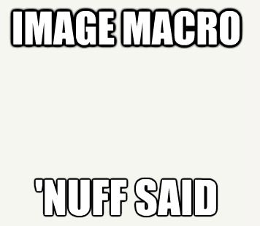

* Reaction images
  + The punchline/message is the image
  + When looking at a meme, if the caption sets up the joke that the image finishes, the image is a “reaction” to the setup of the caption. Contrast with image macros, in which the image sets up the context for the joke (think the Socially Awkward Penguin clueing you into the fact that this is going to be a joke about being socially awkward, as opposed to the caption telling you that it’s a socially awkward situation) and the caption fills in the punchline.
  + <https://knowyourmeme.com/memes/my-face-when-mfw-that-face-when-tfw>
  + <https://knowyourmeme.com/memes/reaction-images>



* Exploitables
  + Changing the dialogue text or labeling parts of an image for the punchline
  + You can also be putting images in the meme rather than text (putting someone else's face of a person in a meme)
  + The key is that an image is recontextualized into a joke (either with labels on the image or the image being placed into another image)
  + Balance image and text equally, they need each other
  + Comics
  + <https://knowyourmeme.com/memes/exploitables>
  + Object labeling
    - <https://knowyourmeme.com/memes/object-labeling>

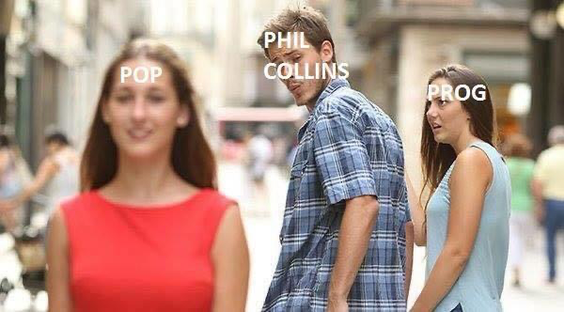

* Duality
  + Drake memes
  + Virgin/chad memes
  + Expectation vs reality
  + Usually comparing two things where one is bad and one is good
    - There can be multiple good or bad things, but if the meme is described in a way where there are good things, bad things, and better things, that’s escalating progression.
* Escalating progression
  + Clown makeup
  + Big brain / galaxy brain
  + Similar to duality but instead of a binary good/bad it can be thought of as an escalation from bad to better to best
    - We should expect all of the things listed in the joke to be more connected in escalating progression than we would in duality
    - There has to be a continuum rather than comparing two different things against one another (even if there’s multiple examples of each comparison), like they have to be escalating in order for it to be escalating progressing
    - One difficult template example: <https://knowyourmeme.com/memes/upgrade-button>
    - 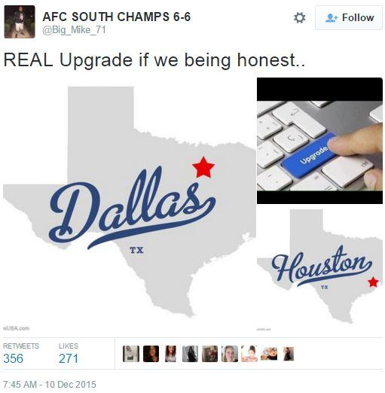
    - The reason why this should be defined as escalation and not duality is that there is a change (progression) from the old city to the new city. Duality does not carry the implication that the bad thing changed into the good thing (from the “upgrade”), but escalating progression does.